NAME: GEORGE REJI
CLASS:S6DS
ROLL NO: 32
DATE: 09-01-2025
EXPERIMENT: 3

data<-c(10,15,20,25,30,35,40,45,50)
print(data)
mean_value<-mean(data)
median_value<-median(data)
firstQ<-quantile(data,0.25)
thirdQ<-quantile(data,0.75)
min_value<-min(data)
max_value<-max(data)
Var_value<-var(data)

cat("Mean:",mean_value,"\n")
cat("median:",median_value,"\n")
cat("First Quantile:",firstQ,"\n")
cat("Third Quantile:",thirdQ,"\n")
cat("Minimum value:",min_value,"\n")
cat("Maximum value:",max_value,"\n")
cat("Variance:",Var_value,"\n")
plot(data)
boxplot(data, main="Boxplot of the Dataset", col="brown",xlab="Values", border="black",horizontal =TRUE)
data2<-c(15,18,23,34,49,53,64,75,86)
print(data2)
cor_value<-cor(data,data2)
cov_value<-cov(data,data2)
cat("Correalation between data and data2:",cor_value,"\n")
cat("Covariance between data and data2:",cov_value,"\n")

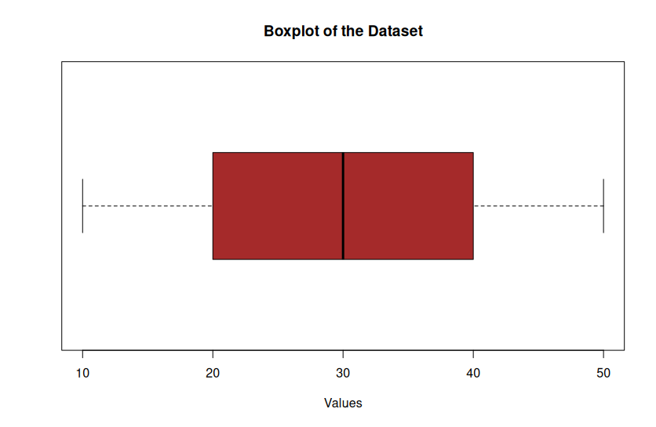

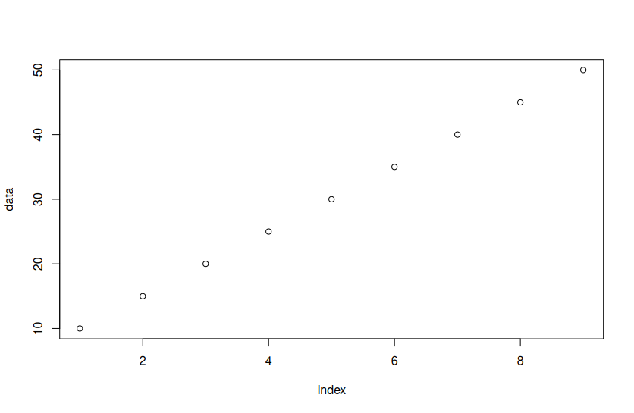

OUTPUT

> data<-c(10,15,20,25,30,35,40,45,50)
> print(data)
[1] 10 15 20 25 30 35 40 45 50
> mean_value<-mean(data)
> median_value<-median(data)
> firstQ<-quantile(data,0.25)
> thirdQ<-quantile(data,0.75)
> min_value<-min(data)
> max_value<-max(data)
> Var_value<-var(data)
> cat("Mean:",mean_value,"\n")
Mean: 30
> cat("median:",median_value,"\n")
median: 30
> cat("First Quantile:",firstQ,"\n")
First Quantile: 20
> cat("Third Quantile:",thirdQ,"\n")
Third Quantile: 40
> cat("Minimum value:",min_value,"\n"
Minimum value: 10
> cat("Maximum value:",max_value,"\n")
Maximum value: 50
> cat("Variance:",Var_value,"\n")
Variance: 187.5
> plot(data)
> boxplot(data, main="Boxplot of the Dataset", col="brown",xlab="Values", border="black",horizontal =TRUE)
> data2<-c(15,18,23,34,49,53,64,75,86)
> print(data2)
[1] 15 18 23 34 49 53 64 75 86
> cor_value<-cor(data,data2)
> cov_value<-cov(data,data2)
> cat("Correalation between data and data2:",cor_value,"\n")
Correalation between data and data2: 0.9915932
> cat("Covariance between data and data2:",cov_value,"\n")
Covariance between data and data2: 347.5
NAME: GEORGE REJI
CLASS:S6DS
ROLL NO: 32
DATE: 09-01-2025
EXPERIMENT: 4

data=data.frame(
x<-c(10,15,20,25,30),
y<-c(10,20,30,40,50) )

varx=var(data$x)
vary=var(data$y)

cat("the variance of x is:",varx,"\n")
cat("the variance of y is:",vary,"\n")

plot(data$x,data$y)

rows=apply(data,1,sum)
cat("row sum is:",rows,"\n")
cols=apply(data,2,sum)
cat("column sum is:",cols,"\n")
totals=sum(rows)

expv=outer(rows,cols)/totals

cor_value<-cor(data$x,data$y)
cov_value<-cov(data$x,data$y)

cat("correlation between x & y",cor_value,"\n")
cat("correlation between x & y",cov_value,"\n")
cat("expected value is:",expv,"\n")

chisq.test(data$x)
chisq.test(data$y)

OUTPUT:
data=data.frame(
+ x<-c(10,15,20,25,30),
+ y<-c(10,20,30,40,50) )
>
> varx=var(data$x)
> vary=var(data$y)
>
> cat("the variance of x is:",varx,"\n")
the variance of x is: 62.5
> cat("the variance of y is:",vary,"\n")
the variance of y is: 250
>
> plot(data$x,data$y)
>
> rows=apply(data,1,sum)
> cat("row sum is:",rows,"\n")
row sum is: 20 35 50 65 80
> cols=apply(data,2,sum)
> cat("column sum is:",cols,"\n")
column sum is: 100 150
> totals=sum(rows)
>
> expv=outer(rows,cols)/totals
>
> cor_value<-cor(data$x,data$y)
> cov_value<-cov(data$x,data$y)
>
> cat("correlation between x & y",cor_value,"\n")
correlation between x & y 1
> cat("correlation between x & y",cov_value,"\n")
correlation between x & y 125
> cat("expected value is:",expv,"\n")
expected value is: 8 14 20 26 32 12 21 30 39 48
>
> chisq.test(data$x)

Chi-squared test for given probabilities

data: data$x
X-squared = 12.5, df = 4, p-value = 0.014

> chisq.test(data$y)

Chi-squared test for given probabilities

data: data$y
X-squared = 33.333, df = 4, p-value = 1.021e-06
